**Assignment # 2**

**Data Structures and Algorithms**

**BSCS – 4-A**

**March, 14th 2017**

**Problem Description**

A polynomial can be represented as a linked list. For every term in the polynomial there is one entry in the linked list consisting of the term's coefficient and the degree. The entries are ordered according to ascending values of degree. Figure 1 illustrates a node that can be used to store a term of a polynomial.

https://lh3.googleusercontent.com/FTctaLaRYEVkHpzqGZlcgbXvCVbgAN3fldjUHdZifAucePJtV3F3Ru3IfZFvgn1KGuDsdEga0XszUlLSynQcBkByql7hmr4rK1UI_kszS9sQya9URRk

Figure 1: A node to store a term of a polynomial

For instance, the polynomial 4x^3 + 6x^2 + 10x+6 will represented as shown in Figure 2.

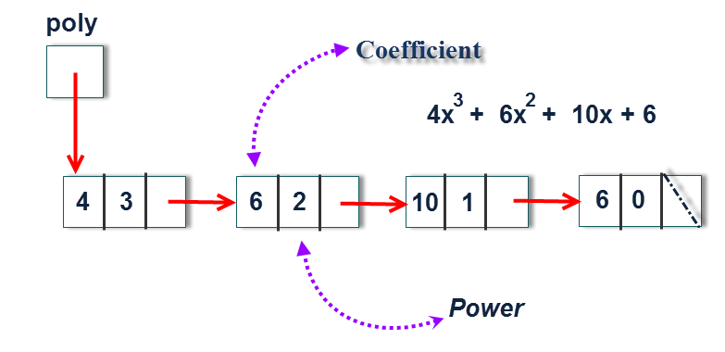

Figure 2: Representation of a polynomial using a linked list

Write a C++ class called Polynomial with the following functionality.

* Read the polynomials from a file.
* Addition of two polynomials.
* Multiplication of two polynomials.
* Evaluation of a polynomial at a given point.

**Sample Output:**

|  |
| --- |
| Enter the name of the polynomial file => ptest1  4.0x^5 + -2.0x^3 + 2.0x + 3.0  1. ADD polynomial  2. MULTIPLY polynomial  3. EVALUATE polynomial  4. QUIT  Enter choice # => 1  Enter the file containing the polynomial to add => ptest2  8.0x^4 + 4.0x^3 + -3.0x + 9.0  Sum: 4.0x^5 + 8.0x^4 + 2.0x^3 + -1.0x + 12.0  1. ADD polynomial  2. MULTIPLY polynomial  3. EVALUATE polynomial  4. QUIT  Enter choice # => 2  Enter the file containing the polynomial to multiply => ptest2  8.0x^4 + 4.0x^3 + -3.0x + 9.0  Product: 32.0x^9 + 16.0x^8 + -16.0x^7 + -20.0x^6 + 52.0x^5 + 38.0x^4 + -6.0x^3 + -6.0x^2 + 9.0x + 27.0 |

**Submission Procedure**

You need to submit a printed copy of your working program with output screen shots. Late submissions are acceptable but with a penalty of 10% per day. **NO CREDIT** for copied assignments.

**Submission Date**

BSCS-4A: Tuesday, 28th, 2017.